vincentprinting.com

Currently we use SendGrid to send mail for Whitelabel customers, vpiuser/vpi160108.

Currently WIX handles our outside service. michael@vincentprinting.com/Printing

EPB fiber optic 648-1500 you need the last four digits of the fed id 0016 to make changes.

Our public ip address is 66.18.42.41.

The following is the list of “A Hosts” currently at WIX.

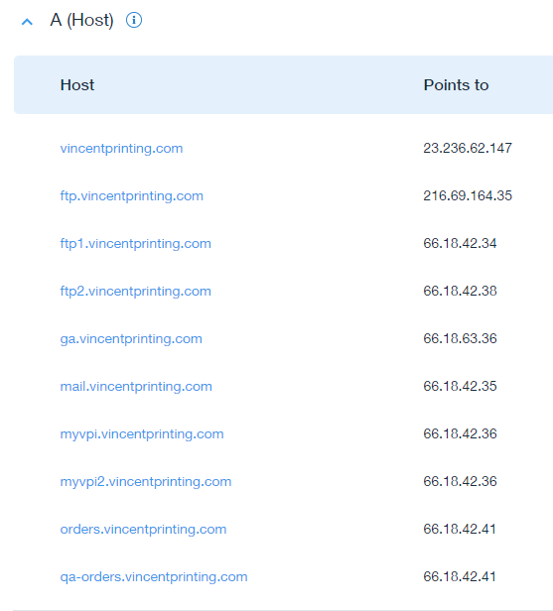

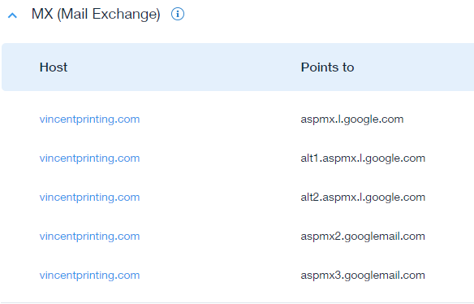

With the MX records you can select the preset records by select the email provider in this case Google. Note: You can enter entries manually by selecting Other from the dropdown.

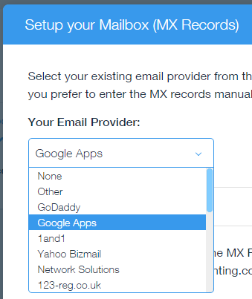 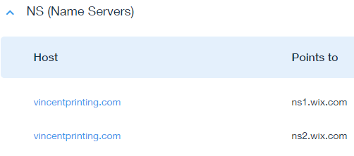

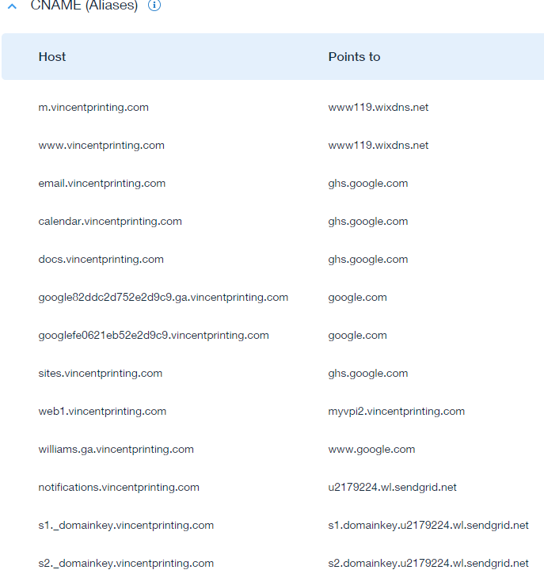

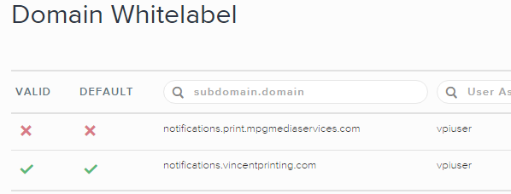

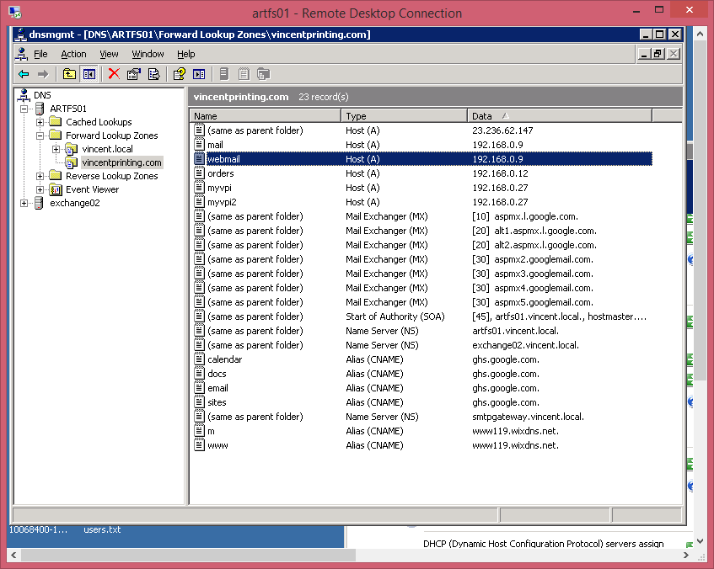

For art load process outside of Bluestreak:

<http://myvpi.vincentprinting.com/> load on to admin site. I think this is the old Dreamweaver site.

Dustin

<http://myvpi2.vincentprinting.com/oiart/artupload.asp>

<http://myvpi2.vincentprinting.com/vpiart/artupload.asp>

Fedex Rate Calculator:

<http://myvpi2.vincentprinting.com/fedrate/FedRate.php>